**Usability Audit of the Zara Web Site**

Zara is a global brand that is based in Spain, has a broad audience, and offers its customers an unparalleled shopping experience. Since its inception, Zara has been at the forefront of the online-shopping space. In this article, I’ll share my analysis of the Zara Web site, examining its functional capabilities and design features to better understand how the brand achieves ecommerce success and caters to the needs of modern consumers.

## The Zara Home Page:

The unconventional home page has both advantages and disadvantages. So before you consider how to implement a similar approach on your Web site without compromising on usability, it’s important that you understand your users and know whether they’ll be able to grasp this design concept. Implementing a unique layout could be appropriate for gaming or fashion-related sites, among others, but it would be odd to see such a layout on the Wal-Mart or Bank of America site.

The Zara home page features a downward-scrolling slider with vibrant photos and video content in the background

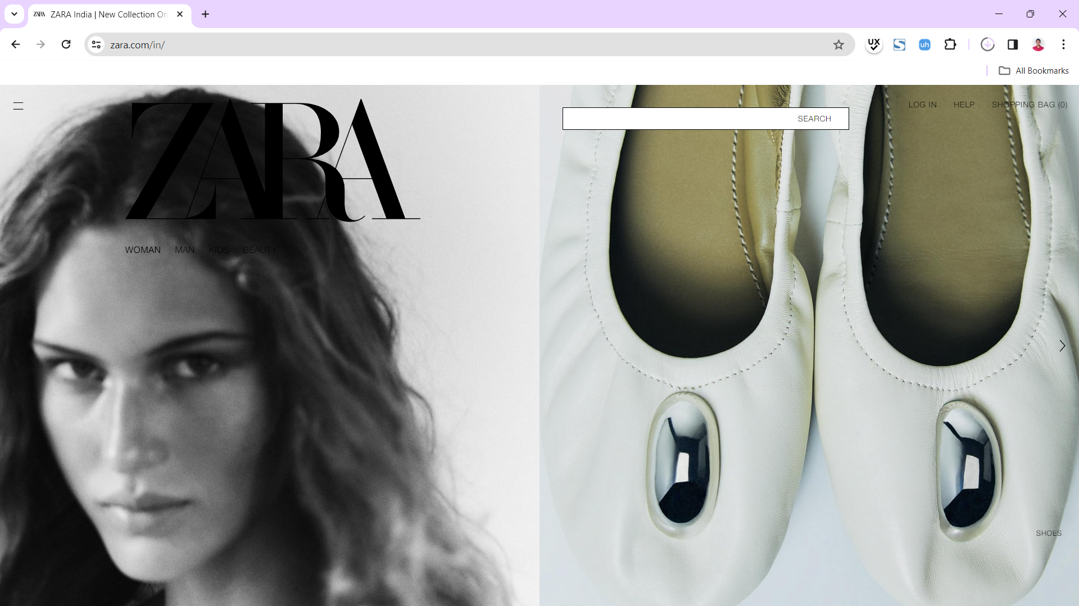

Everything would be fine and dandy, but there’s one catch: the sparkling content distracts the user from the site’s navigational elements. The user could easily get lost because of the excessive cognitive load this imposes. Has Zara resolved this issue as elegantly as their clothing looks? Partially.

In the pursuit of stylish design, Zara’s designers have paid more attention to the appearance of the Web site rather than its usability.

The slider section with its unclear navigation and no clickable elements gives rise to one of the biggest usability issues, which occurs when the user clicks an element, but nothing happens. If you immediately found the New Collection label, you can congratulate yourself on your attentiveness.

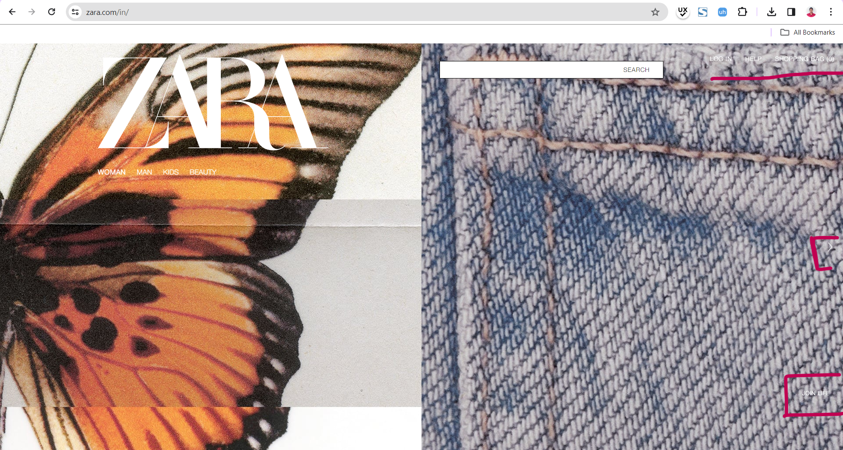

The same issue occurs with the slide about clothing recycling: When changing the background video to the video with a white background, the user can’t see the **Search** box, **Log In** link, or shopping bag. In such cases, it would be better to either use a contrasting background colour for the menu or collapse all the elements into a hamburger icon.

## Product-Category Page:

The product-category page. Greets the user with a large product photo that is centred on the page. Empty space on both sides of that photo could give the impression that the page has not fully loaded. For a moment, I instinctively waited for the rest of the page’s content to appear. Unfortunately, these are all the elements on this page. From a search-engine optimization (SEO) standpoint, the arrangement of elements on the page could be beneficial because search engines scan pages from top to bottom and assign rankings based on the position of the elements in the ranking algorithm

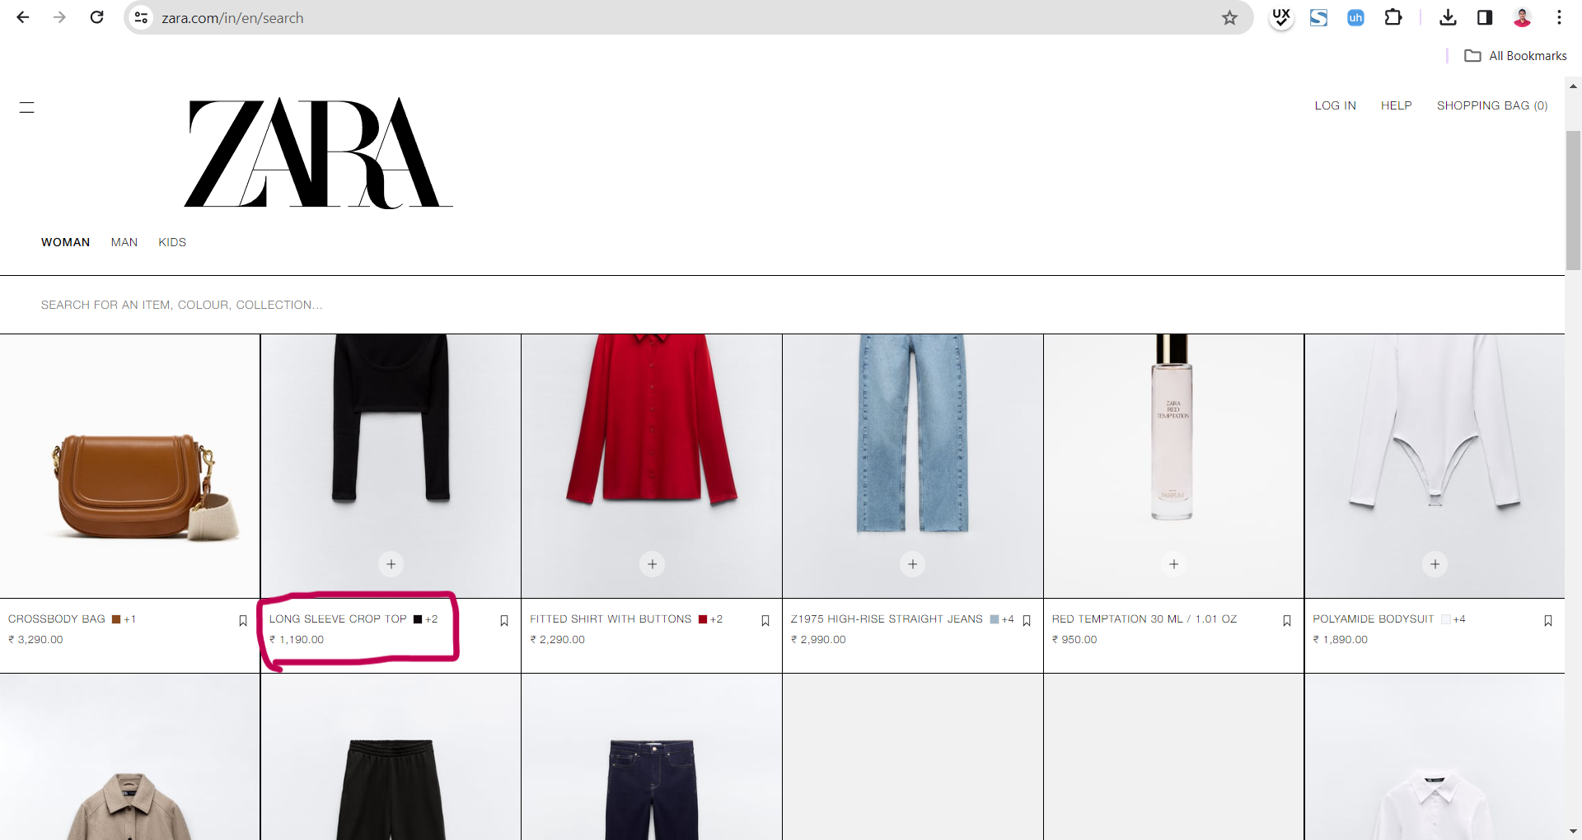

The desktop version of the product page, shown in Figure, is cognitively loading and unreadable because of its numerous elements: an inconvenient gallery, a logo that constantly obstructs useful content and cannot be closed; a small, monotonous font; and a huge cross-selling gallery that is shown in Figure.

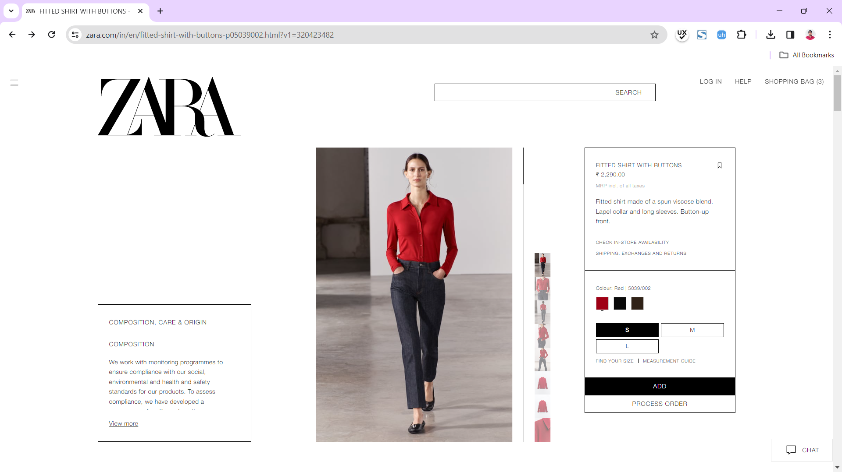

## The Purchasing Process:

As for the shopping bag and the purchasing process, once the user clicks the **Buy** button, the store informs the user that the item has been added to the shopping bag. Users can then choose to continue browsing the Web site or proceed to the shopping bag, shown in Figure, depending on their preference.

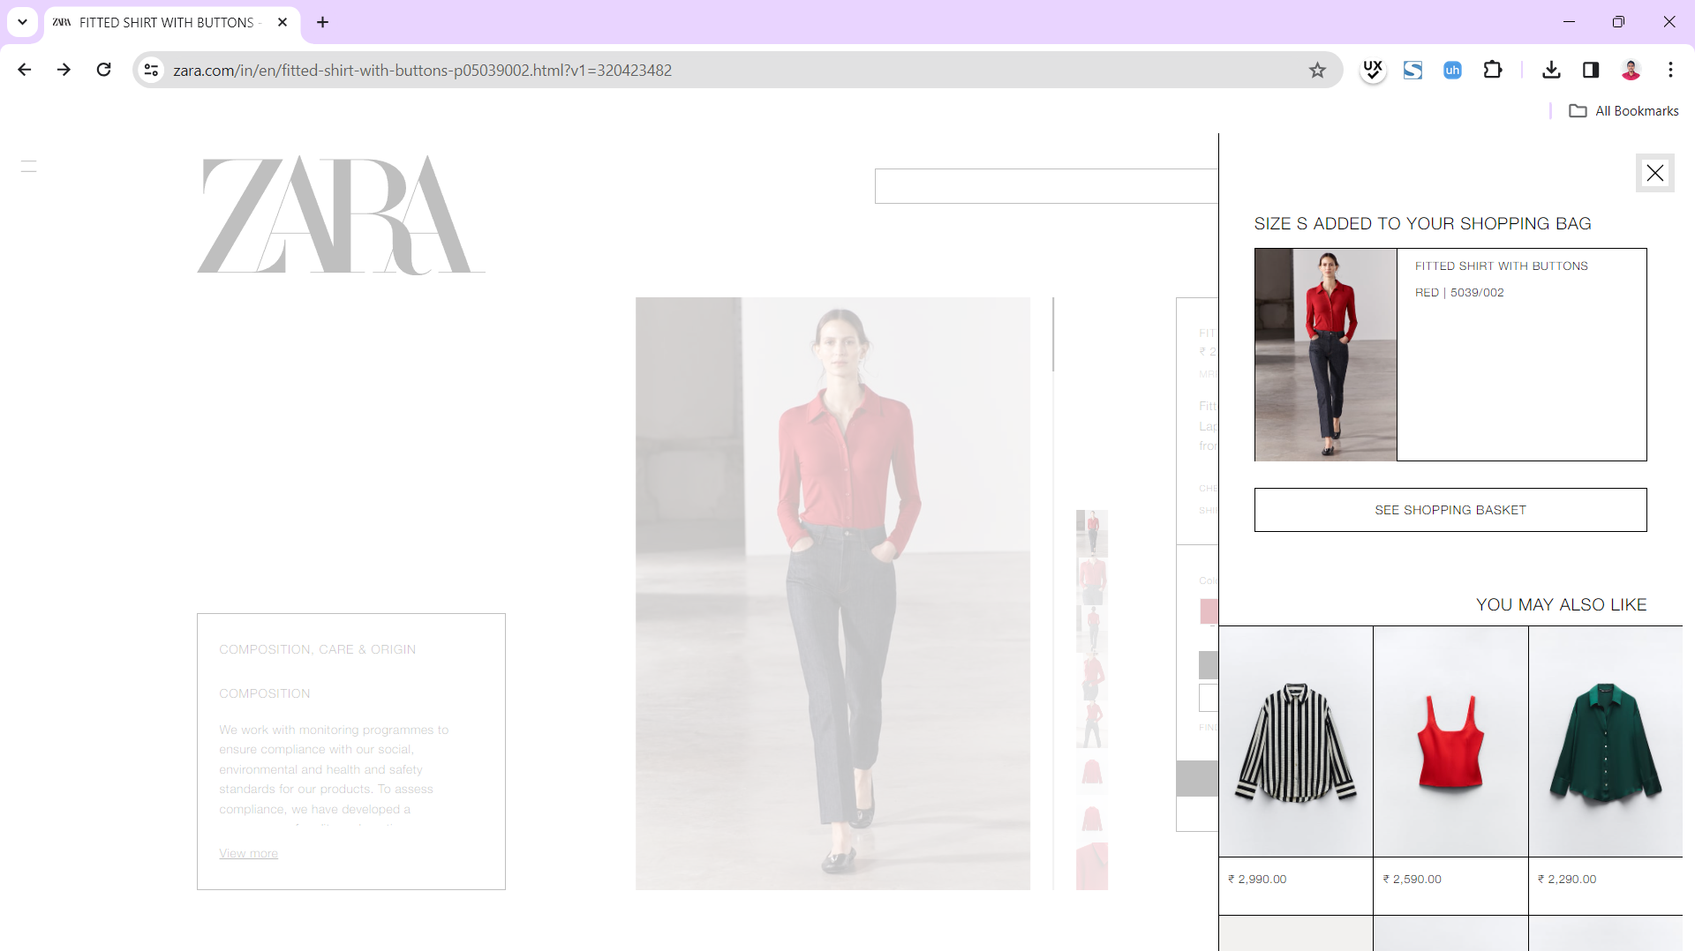

## Registering or Logging In:

Furthermore, users are prompted to register—or log in if they already have an account. During the registration process on the account-creation page, shown in Figure, all required fields are highlighted, and there are helpful hints for filling them out, which is good UX practice. However, there is no **Back** button on the Web site to return to the previous step. For example, if users change their mind about registering, the site doesn’t give them that option. Instead, the user must look for the browser’s **Back** button.

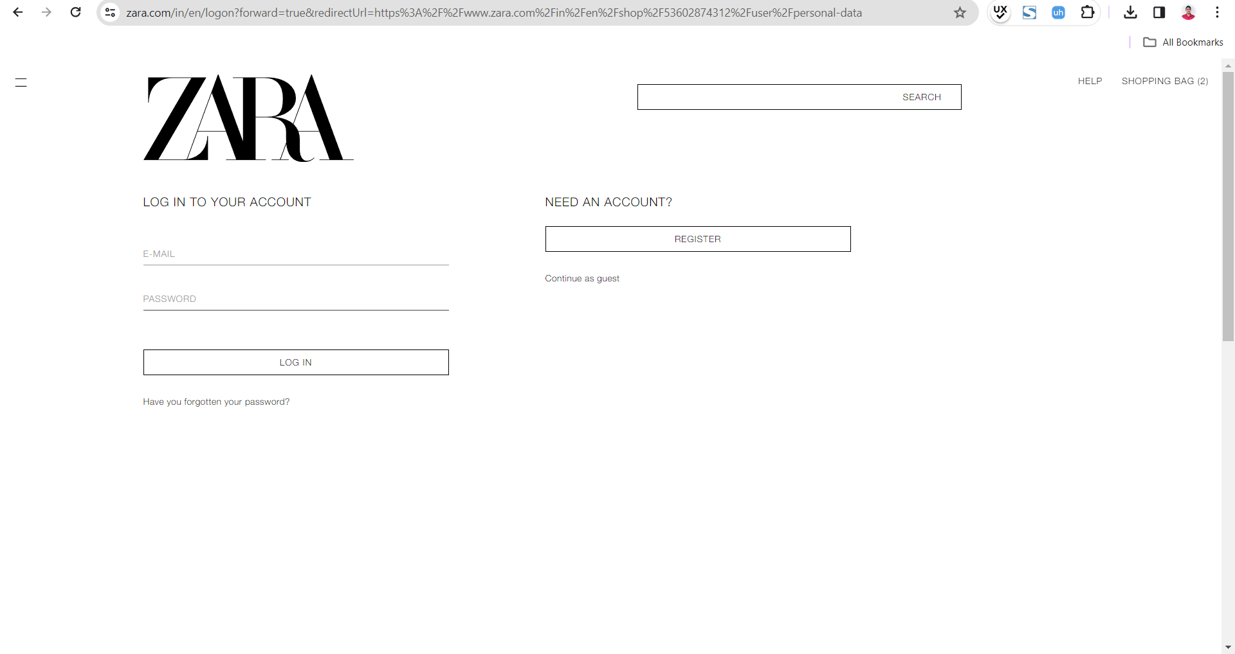

For the user’s convenience, it would be good to implement a fast-track option such as registering through social-media APIs (Application Programming Interfaces) or Gmail. The target audience for such a store typically consists of active social-media users. Moreover, this would make it more convenient for customers to track their purchases and share their experiences on social networks, which would further boost the brand’s ratings.

## In Conclusion:

What learning’s from this article could you apply to a Web site?

### Positive aspects to consider:

* Mobile responsiveness: Do mobile-first design to ensure that all components of a Web site are adequately responsive. Good conversion rates rely on this.
* Accessibility: Show that you care about users with disabilities and special needs.
* Well-designed search: Focus on the search bar’s clickable functionality and provide search suggestions.
* SEO-optimized content: Pay attention to the positioning and content of the text on category pages.

### Negative aspects to avoid:

* Overemphasizing the mobile version: Remember, people still use desktop and notebook computers, so give them a chance to easily make purchases.
* Insufficient filtering options: Identify important product characteristics and add them to the filtering options.
* Lack of sorting options: Make searching and purchasing products as easy as possible for users. Sorting is one way to achieve this.
* Easy-to-understand buttons: Ensure that all buttons have a clearly identified purpose for example, social-media sharing buttons.
* Chabot functionality: If you implement a chatbot, give it a specific function such as material calculation or clothing selection. Remember, the chatbot should serve as a salesperson, and the Web site should provide a usable, real-world experience.
* Ability to go back a step in the shopping bag: Include a **Back** button in the shopping bag for user convenience.

The Zara Web site still has a long way to go in terms of improving its usability and enhancing the user experience. However, with the necessary improvements, it could become a role model for both style and usability.